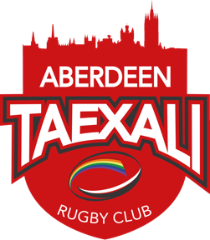
ABERDEEN TAEXALI RUGBY CLUB COMMITTEE
Media and Publicity Rep

Profile:
The main point of contact between the club and the media. Ensuring that the club's promotional expectations are met and the club's brand is reflected in the correct manner across all online and offline media outlets.

Duties / Responsibilities:
- Developing and maintaining a coherent and appropriate marketing strategy. Reflecting the club’s values and aims.
- Responsibility for engagement with the club's external stakeholders including sponsors and developing those relationships. Working with appropriate committee members in doing this.
- Managing the club's social media accounts. Ensuring each account is being used in the most effective manner and follows Taexali brand and messaging guidelines.
- Working closely with the events coordinator to organise events which promote the club and publicising these to members of the public, key stakeholders and press (where suitable)
- Answering enquiries from the press or other media representatives
- Writing and distributing press releases and features as required and supporting other players and members of the committee at press conferences or media interviews
- Generating campaign and press ideas to gain more media coverage
- Dealing with any negative press coverage in a responsible manner

Qualities & Skills
- Excellent communication skills, both written and oral
- An excellent working knowledge of IT and applications relating to communications including social media platforms
- Strong interpersonal skills
- Strong organisational skills
- The ability to write press releases and news reports
- An excellent knowledge of regional and national media
- The ability to work well under pressure
- The ability to work well as a team, as well as work using own initiative
- Creativity
- Close attention to detail
- The ability to cope with criticism
- A friendly, approachable and confident manner

